EXP NO:2 CHARACTERISTICS STUDY OF SIDE BAND POWER ANDFREQUENCIES IN AM USING MATLAB

Objectives:
i) To generate an Amplitude Modulated (AM) signal in MATLAB using specified carrier and
modulating signal parameters.
ii) To determine and verify the upper sideband (USB) and lower sideband (LSB) frequencies of
the AM signal using frequency spectrum analysis in MATLAB.
iii) To calculate the carrier power, sideband power, and total transmitted power of the AM signal
for a given modulation index using MATLAB.
iv) To analyze the effect of varying the modulation index on sideband power distribution and
overall transmission efficiency through MATLAB simulation.
Objective 1:
To generate an Amplitude Modulated (AM) signal in MATLAB using specified carrier and
modulating signal parameters
PROGRAM (MATLAB CODE)
clc;
clear;
close all;
Am=1;
fm=500;
Ac=5;
fc=5000;
fs=20*fc;
t=0:1/fs:4/fm;
m = Am*sin(2*pi*fm*t);
c = Ac*sin(2*pi*fc*t);
mu = Am/Ac;
am = Ac*(1+mu*sin(2*pi*fm*t)).*sin(2*pi*fc*t);
dem = abs(hilbert(am)); dem = dem-mean(dem);
N=length(am); f=linspace(-fs/2,fs/2,N);
AM_FFT=abs(fftshift(fft(am)))/N;
USB=fc+fm; LSB=fc-fm;
Pc=Ac^2/2; Psb=(mu^2*Pc)/4;
figure('Name','AM Modulation','NumberTitle','off');
subplot(3,2,1), plot(t,m), title('Message'), grid on
subplot(3,2,2), plot(t,c), title('Carrier'), grid on
subplot(3,2,3), plot(t,am), title('AM Signal'), grid on
subplot(3,2,4), plot(t,dem), title('Demodulated'), grid on
subplot(3,2,5), plot(f,AM_FFT), xlim([fc-3*fm fc+3*fm]), title('Sidebands'), grid on
subplot(3,2,6), bar([Pc Psb Psb]), set(gca,'XTickLabel',{'Carrier','USB','LSB'}),
title('Power'), grid on
fprintf('μ=%.2f | USB=%d Hz | LSB=%d Hz | Pc=%.2f W | Psb=%.3f
W\n',mu,USB,LSB,Pc,Psb);

OUTPUT (GRAPH)
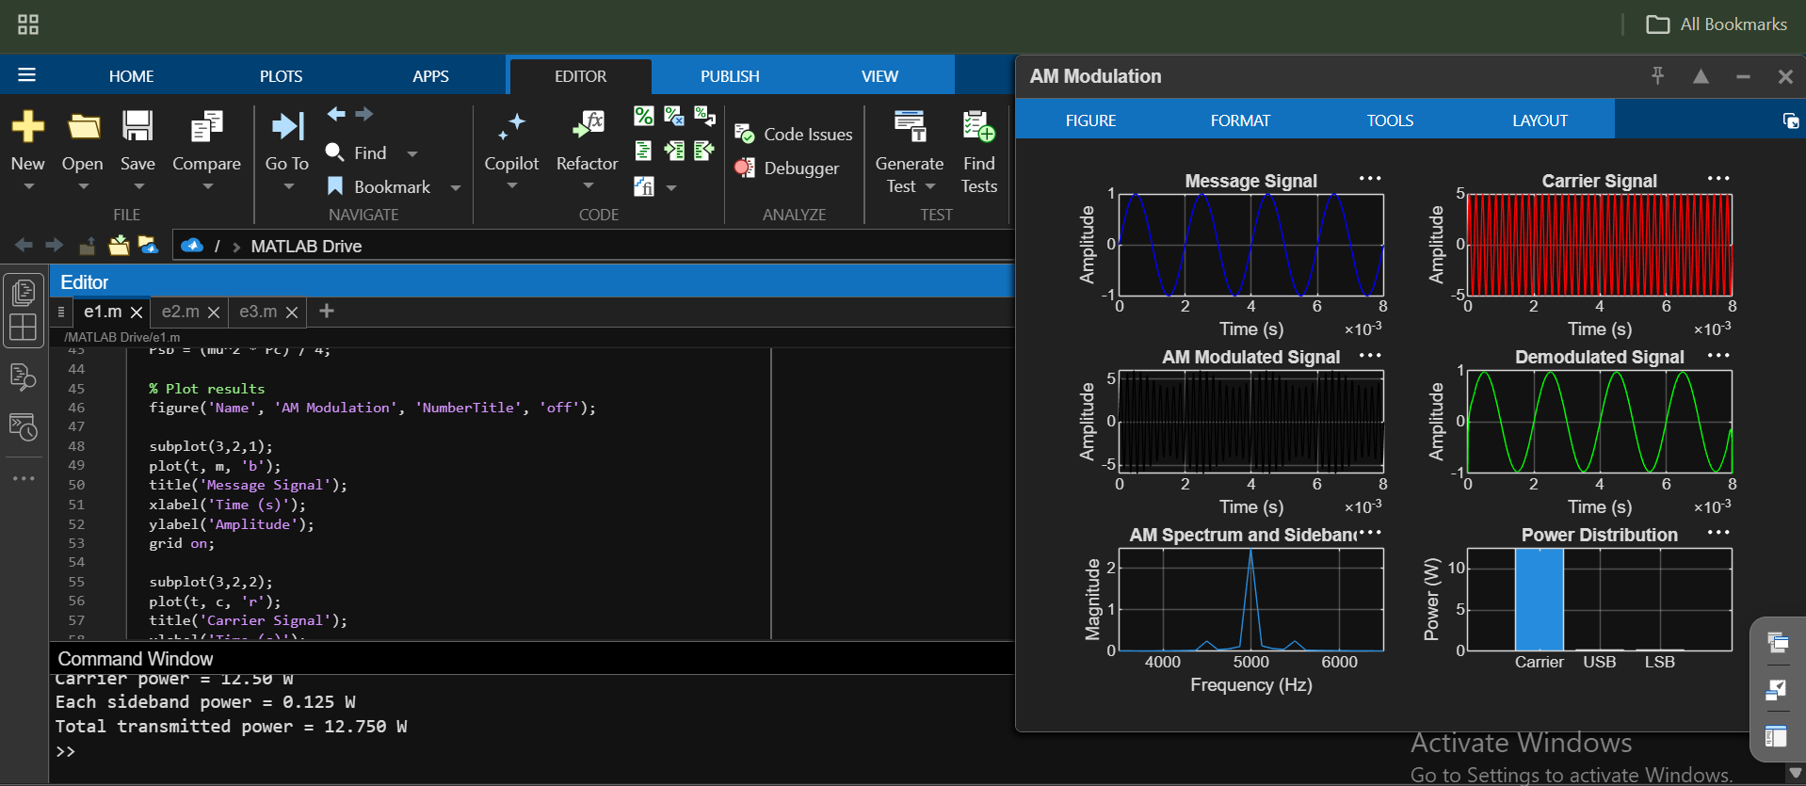
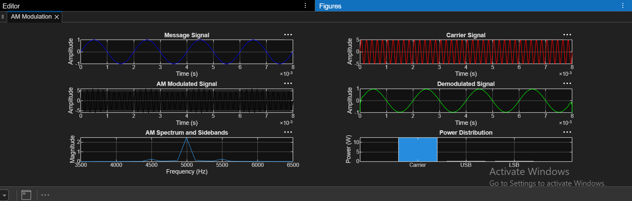

Objective 2:
To determine and verify the upper sideband (USB) and lower sideband (LSB) frequencies of the
AM signal using frequency spectrum analysis in MATLAB.
Program:
clc;
clear;
close all;
% Signal parameters
Am = 1;
fm = 500;
Ac = 5;
fc = 5000;
fs = 20*fc;
% Time vector
t = 0:1/fs:4/fm;
% Generate message and carrier signals
m = Am*sin(2*pi*fm*t);
c = Ac*sin(2*pi*fc*t);
% Generate AM signal
mu = Am/Ac;
am = Ac*(1 + mu*sin(2*pi*fm*t)).*sin(2*pi*fc*t);
% FFT analysis
N = length(am);
Y = fft(am);
P = abs(fftshift(Y))/N;
f = (-floor(N/2):ceil(N/2)-1)*(fs/N);

% Calculate USB and LSB frequencies
USB = fc + fm;
LSB = fc - fm;
% Display results
fprintf('Carrier Frequency = %d Hz\n', fc);
fprintf('Message Frequency = %d Hz\n', fm);
fprintf('Upper Sideband (USB) = %d Hz\n', USB);
fprintf('Lower Sideband (LSB) = %d Hz\n', LSB);
% Plot frequency spectrum
figure;
plot(f, P, 'b', 'LineWidth', 1.2);
xlim([fc-2*fm fc+2*fm]);
xlabel('Frequency (Hz)');
ylabel('Magnitude');
title('AM Signal Frequency Spectrum');
grid on;
% Mark carrier, USB, and LSB frequencies
hold on;
xline(LSB, '--r', 'LSB = 4500 Hz');
xline(fc, '--k', 'Carrier = 5000 Hz');
xline(USB, '--g', 'USB = 5500 Hz');
hold off;

Output:
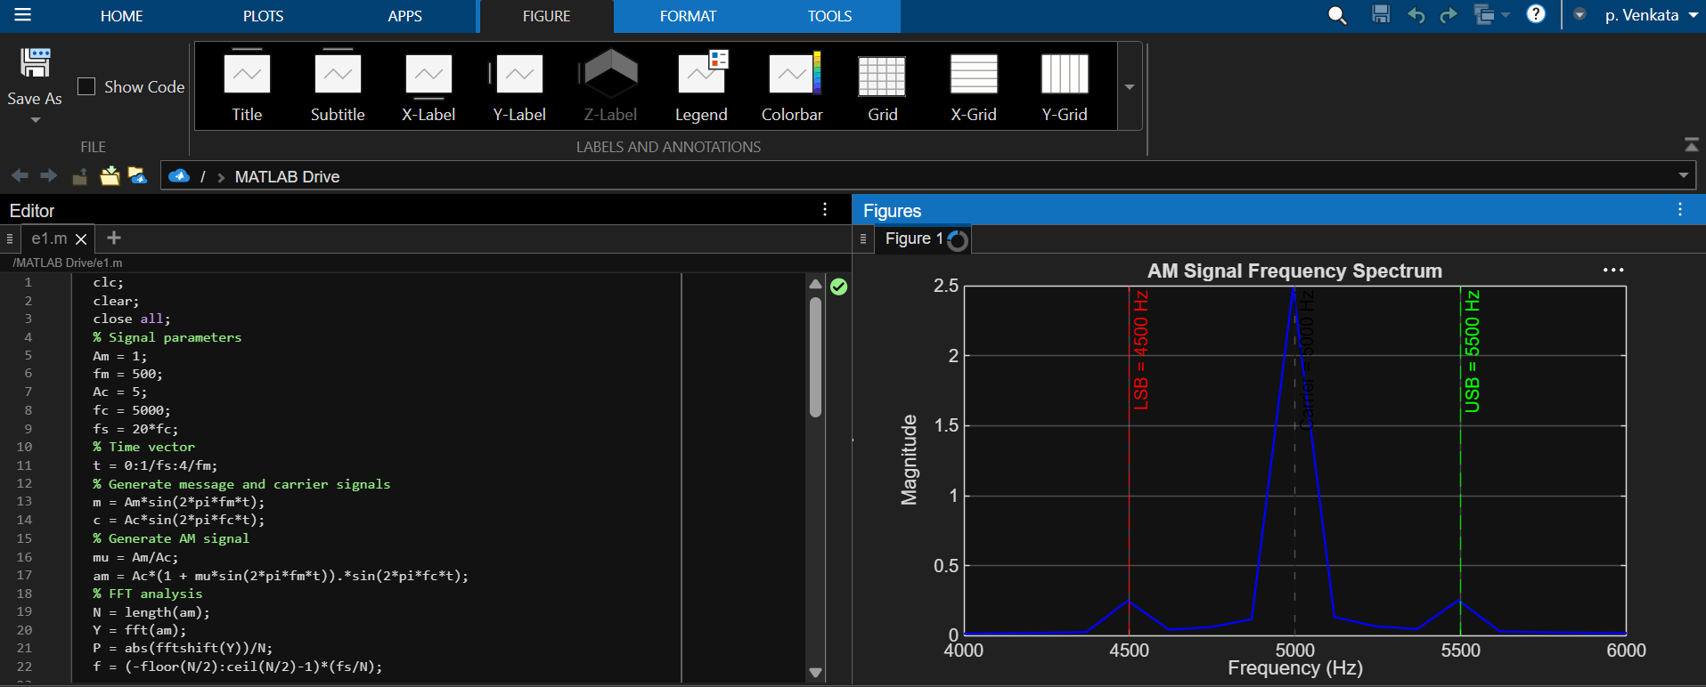
Objective 3:
To calculate the carrier power, sideband power, and total transmitted power of the AM signal for
a given modulation index using MATLAB.
Program:
clc;
clear;
close all;
% Given parameters
Ac = 5; % Carrier amplitude
mu = 0.2; % Modulation index
R = 1; % Load resistance in ohms
% Calculate carrier power
Pc = Ac^2/(2*R);
% Calculate sideband powers
P_USB = (mu^2*Pc)/4;
P_LSB = (mu^2*Pc)/4;
% Total sideband power
P_SB = P_USB + P_LSB;
% Total transmitted power
P_total = Pc + P_SB;
% Display results
fprintf('Modulation Index = %.2f\n', mu);
fprintf('Carrier Power = %.3f W\n', Pc);
fprintf('USB Power = %.3f W\n', P_USB);
fprintf('LSB Power = %.3f W\n', P_LSB);
fprintf('Total Sideband Power = %.3f W\n', P_SB);
fprintf('Total Transmitted Power = %.3f W\n', P_total);
% Plot power distribution
figure('Name','AM Power Calculation','NumberTitle','off');
power = [Pc P_USB P_LSB P_total];
labels = {'Carrier','USB','LSB','Total Power'};
bar(power);
set(gca,'XTick',1:4);
set(gca,'XTickLabel',labels);
ylabel('Power (W)');
title('AM Signal Power Distribution');
grid on;

output:
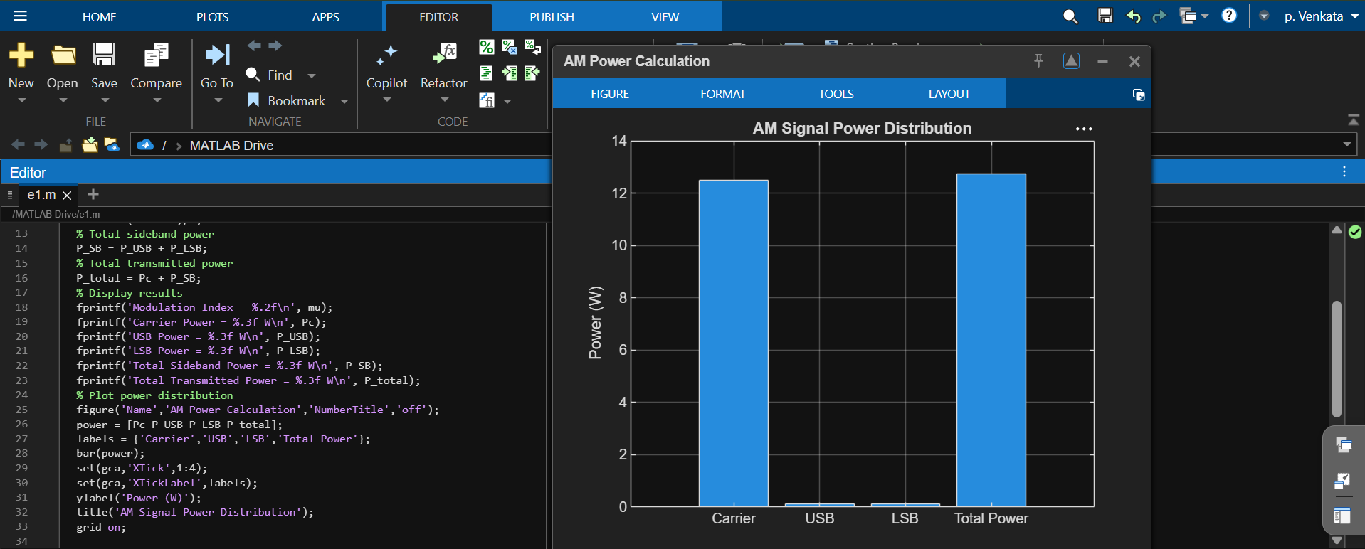
OBJECTIVE 4
iv) To analyze the effect of varying the modulation index on sideband power distribution and
overall transmission efficiency through MATLAB simulation.
PROGRAM:
clc;
clear;
close all;
% Parameters
Ac = 5; % Carrier amplitude
R = 1; % Load resistance in ohms
mu = 0:0.1:1; % Modulation index from 0 to 1
% Carrier power
Pc = (Ac^2)/(2*R);
% Calculate sideband and total power
P_USB = (mu.^2 * Pc)/4;
P_LSB = (mu.^2 * Pc)/4;
P_SB = P_USB + P_LSB;
P_total = Pc + P_SB;
% Calculate transmission efficiency
efficiency = (P_SB ./ P_total)*100;
% Display results
fprintf(' AM Modulation Index Analysis\n');
fprintf('---------------------------------------------\n');
fprintf(' mu USB(W) LSB(W) Total SB(W) Total P(W) Efficiency(%%)\n');
fprintf('---------------------------------------------\n');
for k = 1:length(mu)
fprintf('%.1f %.3f %.3f %.3f %.3f %.2f\n', ...
mu(k), P_USB(k), P_LSB(k), P_SB(k), ...
P_total(k), efficiency(k));
end
% Plot 1: Sideband power distribution
figure('Name','Sideband Power Distribution', ...
'NumberTitle','off');
plot(mu, P_USB, '-o', 'LineWidth', 1.5);
hold on;
plot(mu, P_LSB, '-s', 'LineWidth', 1.5);
plot(mu, P_SB, '-^', 'LineWidth', 1.5);
xlabel('Modulation Index (\mu)');
ylabel('Power (W)');
title('Effect of Modulation Index on Sideband Power');
legend('USB Power','LSB Power','Total Sideband Power', ...
'Location','northwest');
grid on;
hold off;
% Plot 2: Total transmitted power
figure('Name','Total Transmitted Power', ...
'NumberTitle','off');
plot(mu, P_total, '-o', 'LineWidth', 1.5);
xlabel('Modulation Index (\mu)');
ylabel('Power (W)');
title('Modulation Index vs Total Transmitted Power');
grid on;
% Plot 3: Transmission efficiency
figure('Name','Transmission Efficiency', ...
'NumberTitle','off');
plot(mu, efficiency, '-o', 'LineWidth', 1.5);
xlabel('Modulation Index (\mu)');
ylabel('Efficiency (%)');
title('Modulation Index vs Transmission Efficiency');
grid on;
output:
